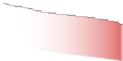
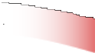
Thank you – OHS Alumni Military Veterans

5th Annual OHS Alumni Military
Veterans’ Breakfast event

This year’s event is to pay special tribute to all
OHS Military Veterans
& the 100th year of the American Legion 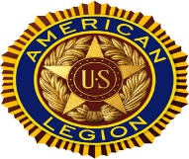

Location: The Oneonta Vets Club, 279 Chestnut St, Oneonta, NY 13280

Date: October 5th, 2019, Time: 0815-1030

Menu
Eggs, Bacon, Sausage, Pancakes, Toast, Coffee, Tea, & Juice

Invited Guests are:

All OHS Alumni military veterans having served on Active Duty, in the
Guard, or the Reserves, their family members, their friends, volunteers who have been involved in the OHS Veteran Legacy Project,
and any
current organization members affiliated with the Oneonta Vet’s Club

Cost

(Free for) All Veterans age 70 or older & OHS Class of 69” Vets
All other attendees / guests: $5.00 / Children under 12 (free)

Plan to attend then please RSVP ASAP to: OHS_Vets@yahoo.comon

(This request would really help in the meal planning)

or

Pay in advance at the Oneonta Vet’s club by signing the Breakfast Guest book

and giving your cash or check (make payable to the Oneonta Vets Club)

to the Bartender on duty.
*For more about OHS Veteran Legacy Project go to
http://ohsmilitaryvets.com/

